RESUME
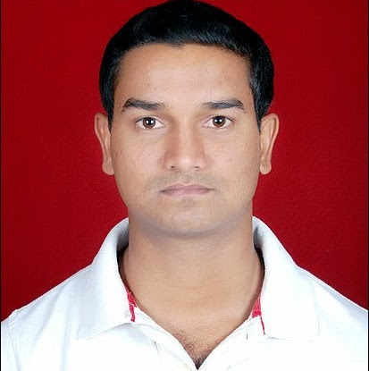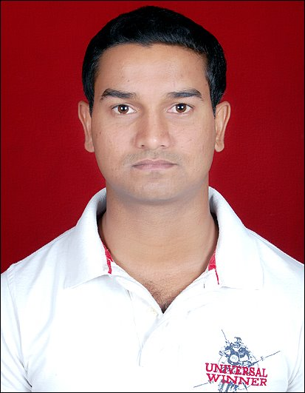
MANISH KUMAR
B.E. (Elect. & Telecom)
Mobile: +91 8826580616
Email.Id: manishkumar.ind01@gmail.com
CAREER OBJECTIVE

To succeed in an environment of growth and excellence which provides me job satisfaction and self development and help me achieve personal as well as organizational goals.

EDUCATIONAL QUALIFICATION
I have completed BE in Electronics and Telecommunication Engineering from Chhattisgarh Institute of Technology, Rajnandgaon (Chhattisgarh Swami Vivekanand Technical University, Bhilai, CG, India).
JOB PROFILE
- Well versed with Basic Database concepts of SQL, PL/SQL, Query Tuning, Query
optimization, PL/SQL Cursor, Views, Materialized Views, DB Triggers, Stored Procedures, Functions, Packages
- Design and Development of new forms and reports as per client request.
- Working experience on Oracle Forms 6i & Oracle Forms 10g/11g.
- Testing of existing data through SQL Script.
- Handling the Production DB issues and used Tools like SQL developer and TOAD.
- Management of schemas, objects, tables & indexes.
- Determine logical design for new changes in consultation with client team and creation
Of new database objects
- Knowledge of SQL* Loader Utility
- Responsible for optimizing the queries and application tuning.

ACADEMIC& PROFESSIONAL PROFILE
S. no. | Qualifications | Institute Name | Board/University | Percentage
1 | B.E. (Electronic & Telecommunication) | Chhattisgarh Institute of Technology , Rajnandgaon (C.G.) | Chhattisgarh Swami Vivekananda Technical University, Bhilai (C.G) | 65.01%
2. | Intermediate(10+2) | Pd. D.D. Upadhyay Inter College, Gopalganj (Bihar) | B.S.E.B. (Patna) | 64.6%
3. | Matriculation(10th) | Gandak High School , Tarwara (Bihar) | B.S.E.B. (Patna) | 65%
TRANING AND CERTIFICATIONS
- Minor Training :National Thermal Power Corporation
Organization :N.T.P.C. Badarpur (New Delhi)
Duration : 30 Days
Department : ET&T

2. Major Training : Chhattisgarh State Electricity Board
Organization : C.S.E.B., Rajnandgaon (C.G.)
Duration : 30Days
Department :ET&T

ACADEMIC PROJECT REPORTS
Project Report:
- Minor Project:
Title: Detecting Power grid synchronization failure on sensing voltage or frequency beyond acceptable range.

COMPUTER PROFICIENCY
- Operating system : Window-7,Window-8,Window-XP
- Application Language : Oracle SQL, PL/SQL, Oracle Forms/Reports 10g/11g, D2K
- Skills : MS-Office 2007/10
CURRENT COMPANY- GIR Logistics Pvt Ltd. (Apr-2015- Till now)
PROJECT NAME-TMS Client Name: GIR
Design & Development of ERP Modules, Day to day troubleshooting, based on client issues/request.
The system is general enough to encompass all aspects Production and Transport management with up to date reporting of transactions. Basically it manages overall managment of GIR LOGISTICS PVT. LTD.

ACHIEVEMENTS & EXTRACURRICULAR
- Achieved first position in " TECHFLAME " for singing.
- Achieved second position in " TECHNOTRON " for singing.

PERSONAL DETAILS
- Father name : Mr. Vijay Kumar
- Mother Name : Mrs. Geeta Devi
- Date of Birth : 02/MAY/1992
- Marital Status : Single
- Languages Known : English, Hindi
- Nationality : Indian

OTHER INFORMATION
Hobbies / Pursue Actively : Listening & Singing Song , Workout
My Strengths : Interaction & Confidence

DECLARATION
I do hereby declare that the particulars of information and facts stated herein above are true, correct and complete to the best of my knowledge and belief.
Place:
Date: Signature

